Java Multimedia File Manager
Project Documentation – Object-Oriented Design and Programming
Student: Andrei Maican
Course: Proiectare și programare orientate obiect

Table of Contents
Java Multimedia File Manager 1
Table of Contents 1
1. Introduction 1
1.1. Project Objective 1
1.2. Application Overview 2
1.3. Tech Stack 2
2. Application Design (Architecture) 2
2.1. Package Structure 2
2.2. Core Class Responsibilities 2
3. Implementation Details (Key Features) 3
3.1. Feature: Asynchronous GUI (Responsiveness) 3
3.2. Feature: Data Persistence (Save/Load) 3
3.3. Feature: Validation and Exception Handling 4
3.4. Feature: Use of Collections and Arrays 4
4. User Guide 4
4.1. How to Run 4
4.2. Application Usage 5
5. Conclusion 6
5.1. Project Summary 6
5.2. Future Improvements 6
6. Appendix: JavaDoc 6

1. Introduction

1.1. Project Objective
The primary objective of this project was to implement a Java application to manage multimedia files (.mp3, .wav, .jpg, .png) from various locations on a hard drive. Key requirements included adding and removing monitored directories and ensuring all data is saved on exit and restored on startup.

1.2. Application Overview
The final application, "Media Manager," is a desktop program built with Java Swing. It features a main window split into two parts: a list of monitored directories and a list of all found multimedia files. The program adheres to all requirements, modifying data in memory and saving the final state (the list of locations) only upon closing the window. File scanning is performed on a background thread to maintain a responsive user interface.

1.3. Tech Stack
- Core: Java 8+
- GUI: Java Swing (javax.swing)
- File I/O: java.nio.file (Path, Files) & java.io (BufferedReader/Writer)
- Concurrency: java.util.concurrent (ExecutorService for background scanning)

2. Application Design (Architecture)

2.1. Package Structure
To respect the "Separation of Concerns" principle, the source code was organized into a main project package, which is subdivided to create a logical and maintainable flux:
- project.gui: Contains all GUI-related classes (MainFrame.java).
- project.services: Contains the business logic, such as FileScanner.java and LocationService.java.
- project.models: Contains the POJO (Plain Old Java Object) data models (MediaFile.java).
- project.exceptions: Contains the custom exception InvalidLocationException.java.
- project.MainApp: The main entry point of the application.

2.2. Core Class Responsibilities
- MainApp: The entry point. It sets the native system Look and Feel and launches the MainFrame on the Swing Event Dispatch Thread (EDT).
- MainFrame: The central GUI class. It builds the window, handles all user events (button clicks), and coordinates the services to display data.
- LocationService: Manages the in-memory List<Path> of locations. It implements loadLocations() and saveLocations() to read from and write to location.txt.
- FileScanner: Responsible for the recursive, I/O-intensive task of scanning directories for supported file types using Files.walk().
- MediaFile: A simple data model class to store the name, path, and size of a found file.

3. Implementation Details (Key Features)

3.1. Feature: Asynchronous GUI (Responsiveness)
A major challenge was to prevent the GUI from freezing during I/O operations. To solve this, all file scanning is delegated to a separate background thread using an ExecutorService.
- When a user clicks "Add Location" or "Refresh Files," the refreshFilesAction() method is called.
- This method submits the scanning task (fileScanner.scanLocations(...)) to the scanExecutor, immediately freeing the main GUI thread.
- The FileScanner runs on the background thread.
- Once the scan is complete, SwingUtilities.invokeLater is used to safely send the results back to the GUI thread and update the JList model, preventing concurrency errors.

3.2. Feature: Data Persistence (Save/Load)
- Restore: On startup, the MainFrame constructor calls loadInitialData(), which in turn calls locationService.loadLocations(). This reads location.txt and populates the in-memory list before the window is visible.
- Save: To intercept the application closing, the JFrame's default close operation is set to DO_NOTHING_ON_CLOSE. A WindowAdapter is added that overrides windowClosing(). When the user clicks the "X" button, this listener: a. Calls locationService.saveLocations() to write the in-memory list to location.txt. b. Shuts down the scanExecutor. c. Disposes the window and exits the application (System.exit(0)).

3.3. Feature: Validation and Exception Handling
- Custom Exception: InvalidLocationException is a custom checked exception created for this project. It is thrown by LocationService if a path (from the user or location.txt) is not a valid, accessible directory.
- Handling: The MainFrame contains try...catch blocks that specifically catch InvalidLocationException. When caught, a user-friendly JOptionPane dialog is displayed with a clear error message, rather than crashing the application. Standard exceptions like IOException are also handled during file read/write operations.

3.4. Feature: Use of Collections and Arrays
- Arrays: Two fundamental arrays are used:
  - String[] supportedFileTypes: (in MainFrame) to define the scan targets.
  - int[] fileTypeCounts: (in MainFrame) to generate the console report (Requirement #1).
- Collections: Two different collections are used:
  - List<Path> monitoredLocations: (in LocationService) an ArrayList to hold the list of directory paths.
  - DefaultListModel<String> locationListModel: (in MainFrame) a Swing-specific collection model used to dynamically power the JList component. (An ArrayList<MediaFile> is also used internally by FileScanner).

4. User Guide

4.1. How to Run
This project is a standard Java desktop application designed to be compiled and run from the terminal.
1. Open Your Terminal Navigate to the project's root folder (the directory containing the README.md file and the src folder).
2. Create 'bin' Directory Create a bin directory to store the compiled .class files. This keeps the source directory clean.
mkdir bin

3. Compile the Project Compile all the source files from the src directory into the bin directory.
javac -cp src -d bin src/project/MainApp.java src/project/gui/MainFrame.java src/project/models/MediaFile.java src/project/services/FileScanner.java src/project/services/LocationService.java src/project/exceptions/InvalidLocationException.java

4. Run the Application Run the app by specifying the bin folder as your classpath and calling the main class.
java -cp bin project.MainApp
The GUI window will launch.

4.2. Application Usage
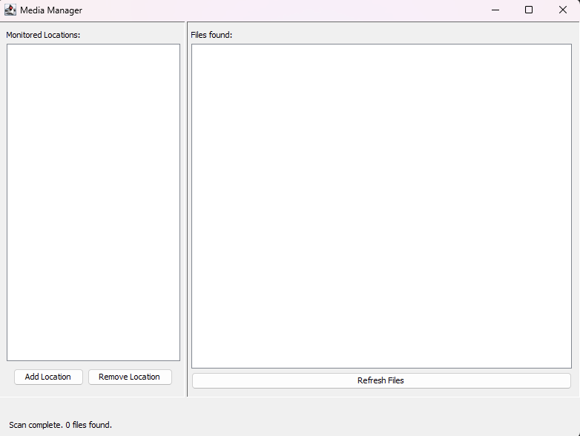
- Add Location: Click the "Add Location" button to open a directory chooser.
- Scan & View Files: Select a folder. The app will automatically scan it (and all subfolders) and display the found files (.jpg, .png, .mp3, .wav) in the "Files found" list on the right.
- Refresh: Click "Refresh Files" to manually trigger a re-scan of all monitored locations.
- Remove Location: Select a location from the "Monitored Locations" list on the left and click "Remove Location" to stop monitoring it.
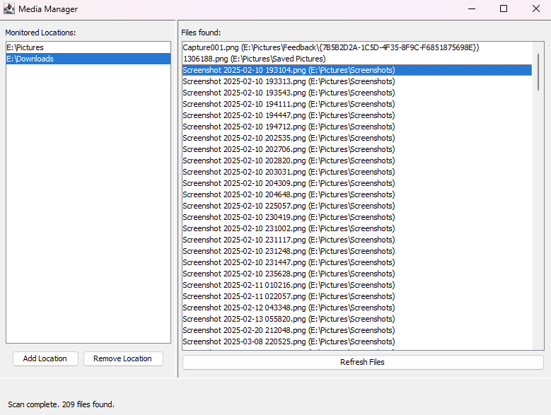
- Save & Exit: Simply close the window. The application automatically saves your list of locations to location.txt and will restore them the next time you open the app.

5. Conclusion
This project successfully fulfilled all 9 requirements for the PPOO course. A stable, event-driven Java Swing application was developed that can manage and scan for multimedia files. Key features include a responsive, multi-threaded GUI, persistent data storage, and robust error handling, all built on a logical, object-oriented architecture.

5.1 JavaDoc
The complete API documentation for all classes and public methods was generated using the javadoc tool.
The documentation is included in the project's doc/javadoc folder.
To view the documentation: Open the doc/javadoc/index.html file in a web browser.

